**Bug Detection and Fixing**

**Intel® Unnati Industrial Training 2025 - Problem Statement 1**

**Author: Pritam Chakrabortty**

**Project Overview**

Bug detection and fixing is a crucial aspect of software development, ensuring code quality, reliability, and efficiency. This project focuses on developing an AI-powered system capable of detecting and automatically fixing bugs in code, thereby reducing manual debugging efforts and improving productivity.

**Problem Statement**

Modern software development faces challenges with debugging, as manual debugging is time-consuming and prone to human error. The need for an automated system that can identify and fix bugs in multiple programming languages is critical for improving code quality and reducing development time.

**Proposed Solution**

The solution involves building an AI-based tool that:

* Accepts code input from users in various programming languages (Python, Java, C, JavaScript).
* Identifies syntax and logical errors in the provided code.
* Generates explanations for detected errors.
* Provides a corrected version of the input code.

This system utilizes a generative AI model to analyze and fix code errors efficiently.

**Implementation Details**

**1. Dataset and Model Training**

* Used a dataset consisting of buggy and corrected code samples.
* Fine-tuned a generative AI model to detect and correct code errors.
* The model was trained using supervised learning with bug-fixing patterns.

**2. Tech Stack**

* **Frontend:** HTML, CSS, JavaScript (Vite framework)
* **Backend:** Python (Flask API)
* **Model:** Gemini-2.0-Flash (used for bug detection and fixing)
* **Deployment:** Render (Cloud-based deployment)

**3. Workflow**

1. User selects a programming language.

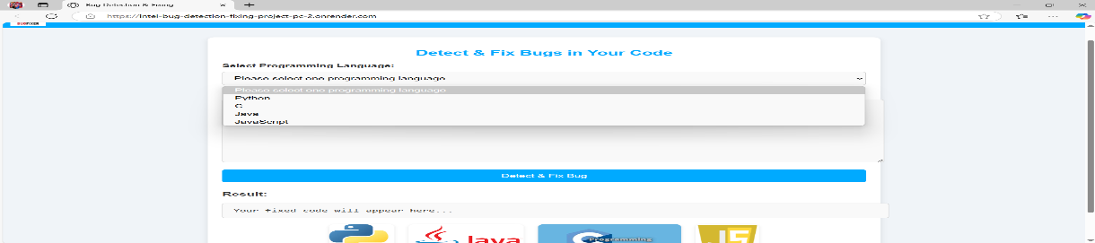

1. User enters the buggy code.

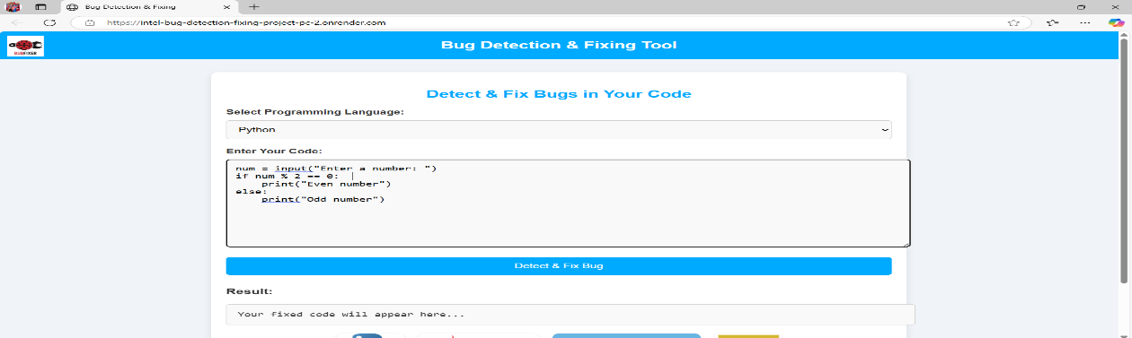

1. The AI model analyzes the code and detects potential errors.
2. The model provides an explanation of the detected error.
3. The fixed version of the code is generated and displayed to the user.

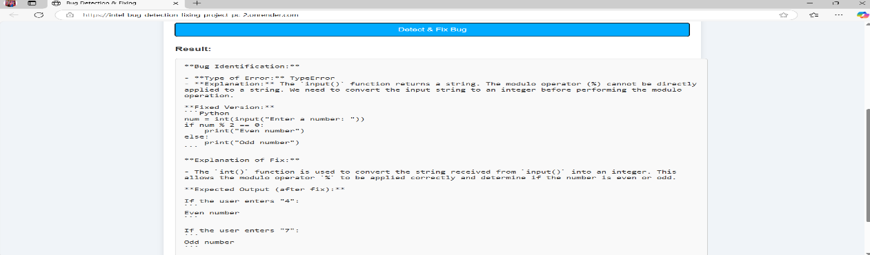

**Features**

* Supports multiple programming languages (Python, C, Java, JavaScript).
* Real-time error detection and fixing.
* User-friendly web interface.
* Explanation of errors for better understanding.

**Deployment Link**

The project has been deployed on Render and can be accessed at: [Bug Detection and Fixing Tool](https://intel-bug-detection-fixing-project-pc-2.onrender.com/)

**GitHub Repository**

The source code and implementation details can be found at: [GitHub Repository](https://github.com/Pritam-Chakrabortty/INTEL-BUG-DETECTION---FIXING-PROJECT-PC)

**Conclusion**

The "Bug Detection and Fixing" project under the Intel® Unnati Industrial Training 2025 addresses a fundamental need in modern software development: minimizing time-consuming and error-prone manual debugging. By leveraging generative AI models like Gemini-2.0-Flash, the system successfully identifies and fixes code bugs in real time across multiple programming languages. This project not only enhances code quality but also provides an educational layer through error explanations, empowering developers and learners alike.

**Reference Review by HOD**

This project has been reviewed and approved by our respected Head of the Department, **Dr. Shivnath Ghosh**. His valuable feedback and insights have helped shape the direction and scope of this project. His endorsement affirms the technical soundness and relevance of the solution in addressing real-world software development challenges.

**Contact**

For any queries, feel free to contact:

* **GitHub:** [Pritam-Chakrabortty](https://github.com/Pritam-Chakrabortty)
* **Email:** [bwubta22388@brainwareuniversity.ac.in](mailto:bwubta22388@brainwareuniversity.ac.in)